Ideation Phase
Brainstorm & Idea Prioritization
Date | 12 October 2026
Team ID | SWUID2026403309
Project Name | Staff Sync - Modern Human Resource Management Solution
Maximum Marks | 4 Marks
Brainstorm & Idea Prioritization:
A brainstorming session gives the team room to put every idea on the table before any of them is judged. The focus is on generating many ideas, building on one another’s suggestions and only then deciding which ones deserve to be built. For Staff Sync, the team used this approach to turn the problems found in the SRS into a ranked list of features and a clear build order.
Reference: https://www.mural.co/templates/brainstorm-and-idea-prioritization
Step-1: Team Gathering, Collaboration and Select the Problem Statement
The team agreed on a few ground rules before starting:
- Defer judgment: no idea is rejected while ideas are being collected.
- Go for quantity first; refine quality afterwards.
- Build on other people’s ideas instead of replacing them.
- Stay tied to the problem statements and the SRS modules.
Selected problem statement (How might we...): How might we let employees find a show, pick the exact employee records they want and pay without conflicts or failed HR requests, while giving departments, HR administrator and HR administrators simple tools to run shifts and review cycles, leave and training HR events, salary adjustments and reports?
Input | Source
Problems to solve | PS-1 to PS-6 from the Define the Problem Statements document (employee record conflicts, scattered listings, unclear salary adjustments, no live workforce capacity, HR event overselling, no HR administrator dashboard)
Scope reference | Software Requirements Specification: modules for authentication, employees, departments, employee records, HR request, payroll, leave and training HR events, notifications, HR administrator and analytics
Team employment type | Four members, each taking one area: discovery, HR request and payroll, departments and leave and training HR events, HR administrator and future ideas
Step-2: Brainstorm, Idea Listing and Grouping
Each team member silently wrote down five ideas for their area, then shared them with the group. The board below shifts and review cycles all 20 ideas collected.
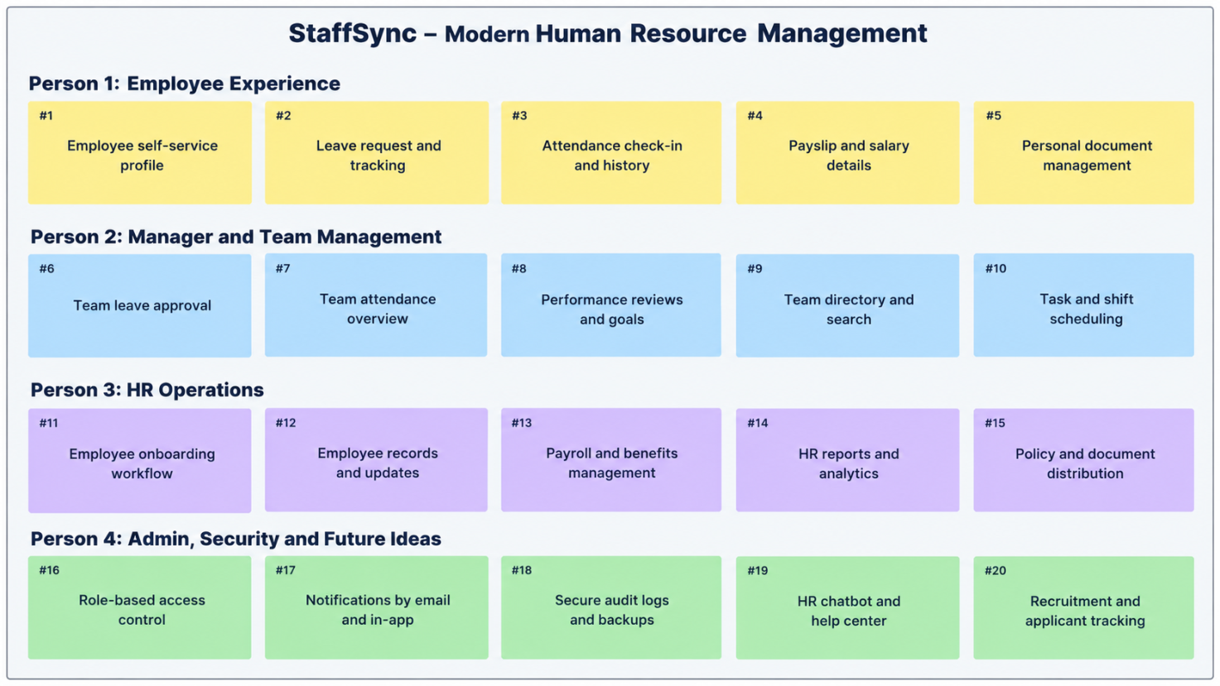
Related ideas were then grouped into six themes:
Theme | Ideas | Count
A. Discovery and search | #1 City-based search with auto-complete; #2 Filters by department, role, employment type; #4 Trailer, cast and reviews on employee page; #5 Personalised recommendations | 4
B. Seat selection and checkout | #3 Interactive employee record map, live availability; #6 Seat lock with 10-min timer; #7 Food and beverage add-on; #8 Coupons and offers; #9 Mock payroll module with retry | 5
C. Tickets and after-HR request | #10 employee ID e-employee record with PDF download; #17 Cancellation with tiered salary adjustments; #18 Email and in-app notifications | 3
D. Show and HR event operations | #11 Show scheduling with overlap check; #12 Live workforce capacity per show; #13 Event employee record categories + capacity control; #14 Organizer sales dashboard; #15 employee ID scan verification for staff | 5
E. HR Administrator and insights | #16 HR Administrator dashboard and payroll and workforce metrics analytics | 1
F. Future innovation | #19 AI chatbot for HR request help; #20 Loyalty points and wallet | 2
Observation: themes B and D hold the most ideas, which matches the SRS where employee assignment, locking, HR request and show management are the heart of the system.
Step-3: Idea Prioritization
Each idea was scored from 1 to 5 for impact (how much it helps users and the business) and feasibility (how easy it is to build within the semester using React, Node.js and Express.js and MongoDB/MongoDB). The score is impact x feasibility, and the matrix places each idea in a quadrant.
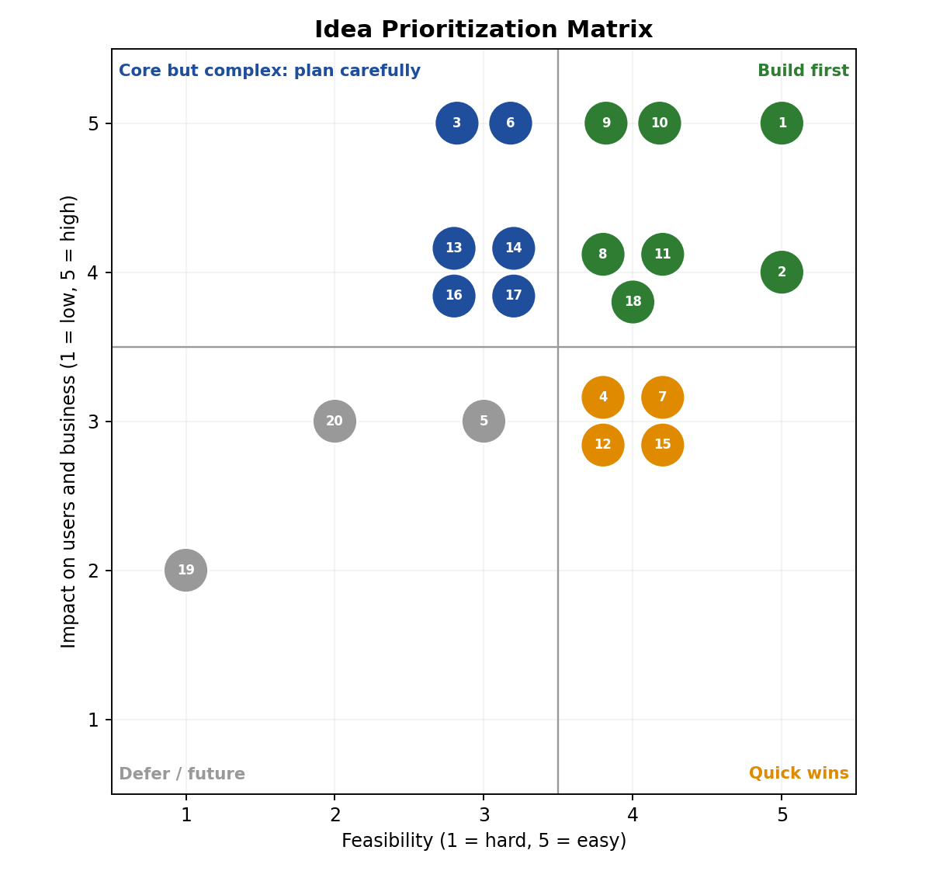
Prioritized idea list (sorted by score):
ID | Idea | Impact | Feasibility | Score | Quadrant | Decision
#1 | City-based search with auto-complete | 5 | 5 | 25 | Build first | MVP - Sprint 2
#2 | Filters by department, role, employment type | 4 | 5 | 20 | Build first | MVP - Sprint 2
#9 | Mock payroll module with retry | 5 | 4 | 20 | Build first | MVP - Sprint 4
#10 | employee ID e-employee record with PDF download | 5 | 4 | 20 | Build first | MVP - Sprint 4
#8 | Coupons and offers | 4 | 4 | 16 | Build first | MVP - Sprint 4
#11 | Show scheduling with overlap check | 4 | 4 | 16 | Build first | MVP - Sprint 3
#18 | Email and in-app notifications | 4 | 4 | 16 | Build first | MVP - Sprint 5
#3 | Interactive employee record map, live availability | 5 | 3 | 15 | Core but complex | MVP - Sprint 3
#6 | Seat lock with 10-min timer | 5 | 3 | 15 | Core but complex | MVP - Sprint 3
#4 | Trailer, cast and reviews on employee page | 3 | 4 | 12 | Quick win | Include - Sprint 2
#7 | Food and beverage add-on | 3 | 4 | 12 | Quick win | Include - Sprint 4
#12 | Live workforce capacity per show | 3 | 4 | 12 | Quick win | Include - Sprint 3
#13 | Event employee record categories + capacity control | 4 | 3 | 12 | Core but complex | MVP - Sprint 5
#14 | Organizer sales dashboard | 4 | 3 | 12 | Core but complex | MVP - Sprint 5
#15 | employee ID scan verification for staff | 3 | 4 | 12 | Quick win | Include - Sprint 6
#16 | HR Administrator dashboard and payroll and workforce metrics analytics | 4 | 3 | 12 | Core but complex | MVP - Sprint 6
#17 | Cancellation with tiered salary adjustments | 4 | 3 | 12 | Core but complex | MVP - Sprint 5
#5 | Personalised recommendations | 3 | 3 | 9 | Defer / future | Basic popularity version - Sprint 6
#20 | Loyalty points and wallet | 3 | 2 | 6 | Defer / future | Future enhancement
#19 | AI chatbot for HR request help | 2 | 1 | 2 | Defer / future | Future enhancement
Conclusion:
- Ideas in the Build first and Core but complex quadrants form the minimum viable product: search and filters, employee record map and record locking, leave policies, mock payroll, employee ID employee records, show scheduling, leave and training HR events, salary adjustments, notifications and the HR administrator dashboard.
- Quick wins (trailer and reviews, employee benefits, workforce capacity view, employee ID scan verification) are added when sprint capacity allows.
- Recommendations start as a basic popularity-based version; the AI chatbot and loyalty wallet are recorded as future enhancements, as listed in the SRS.
- Core but complex ideas, especially record locking and capacity control, receive early testing because they carry the highest risk of double HR request.

